1.

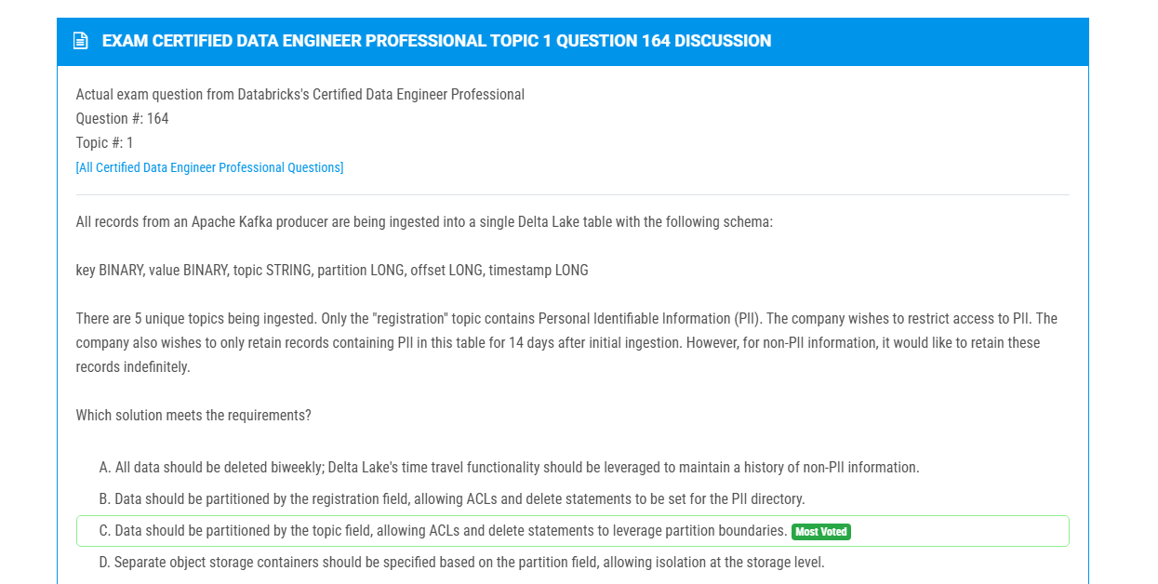  
  
2. 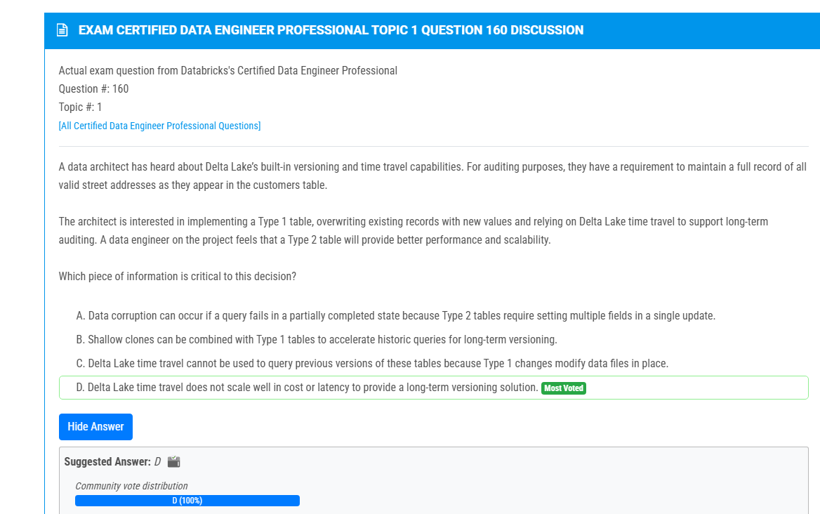  
  
4. 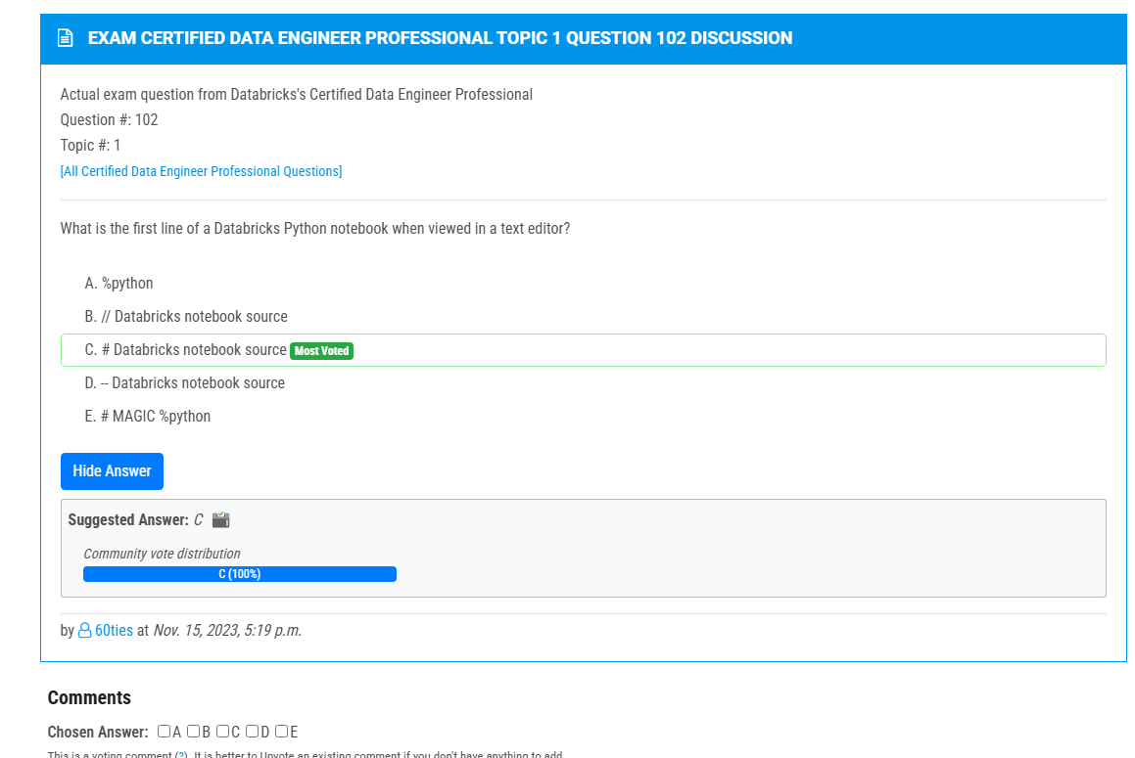  
5.

7. 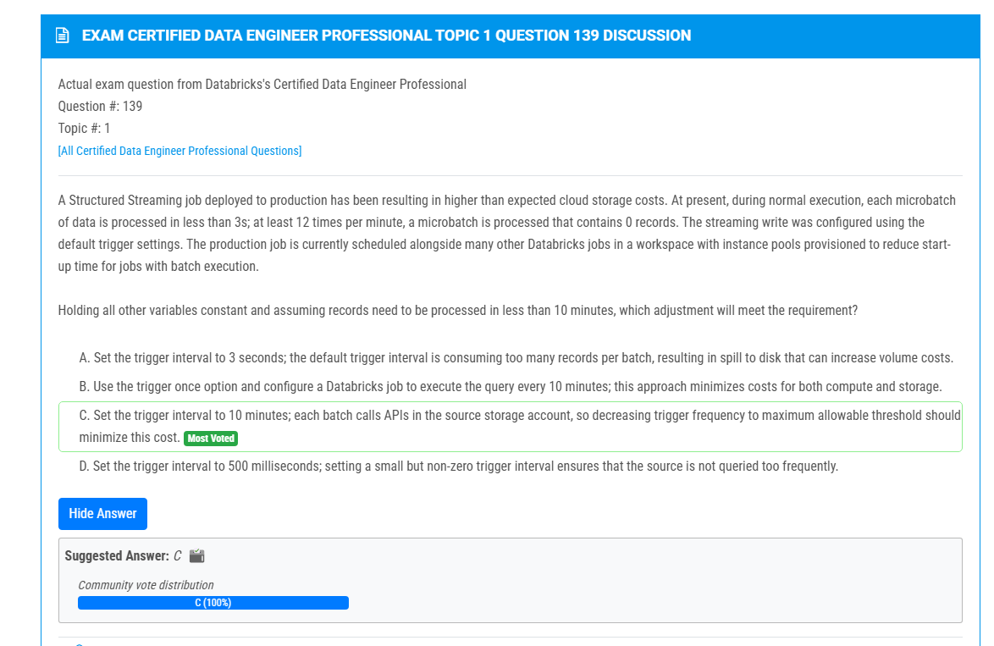  
9.  
  
  
10. 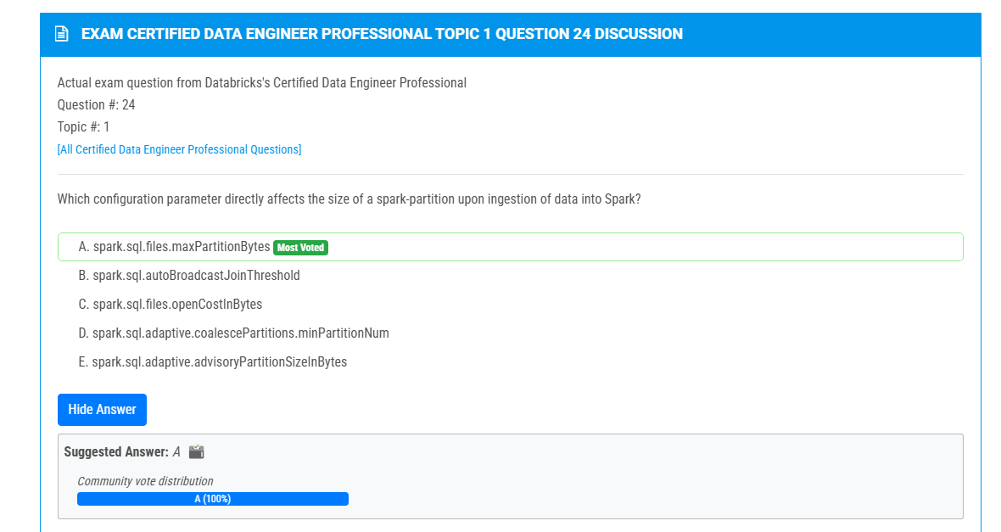

14. 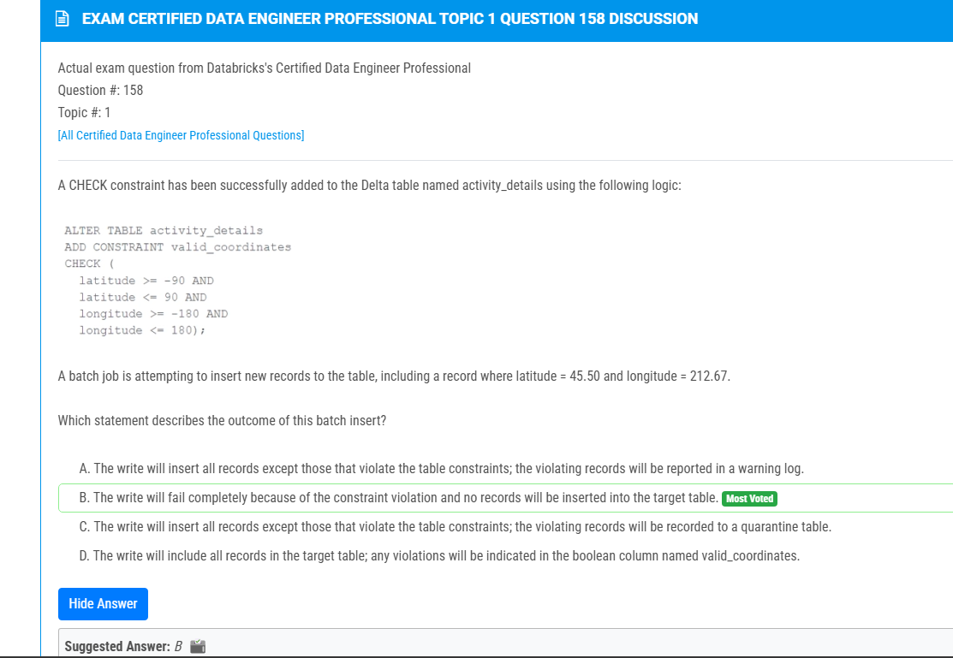

21. 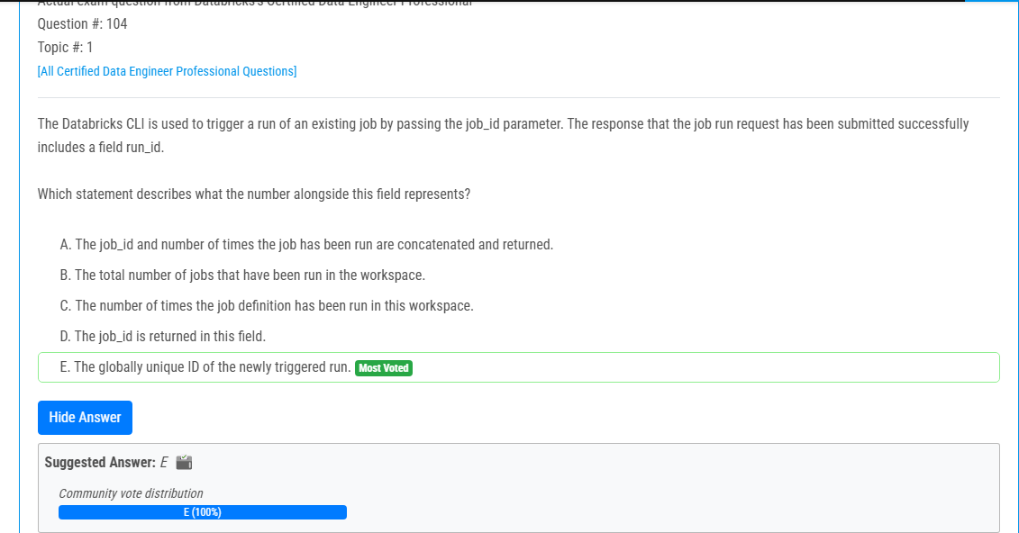

28. 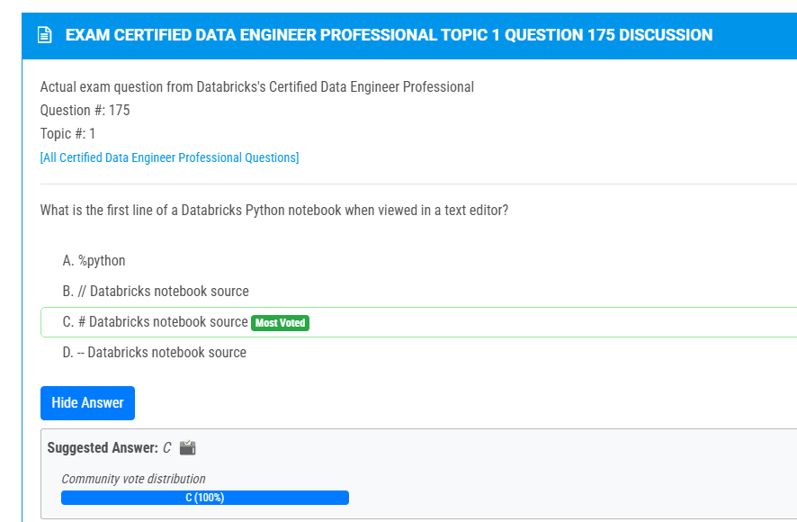

29. 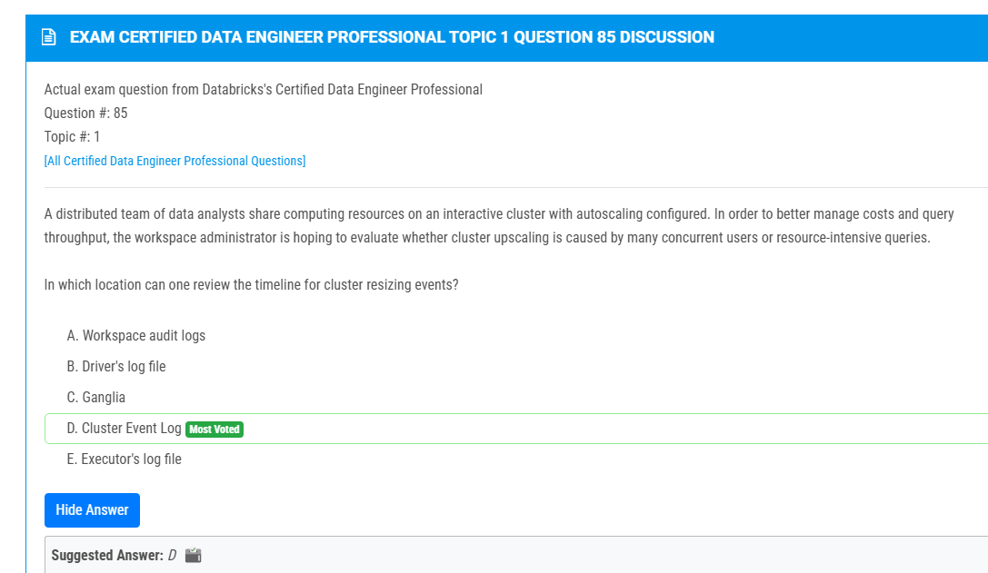

32.  
  
33. 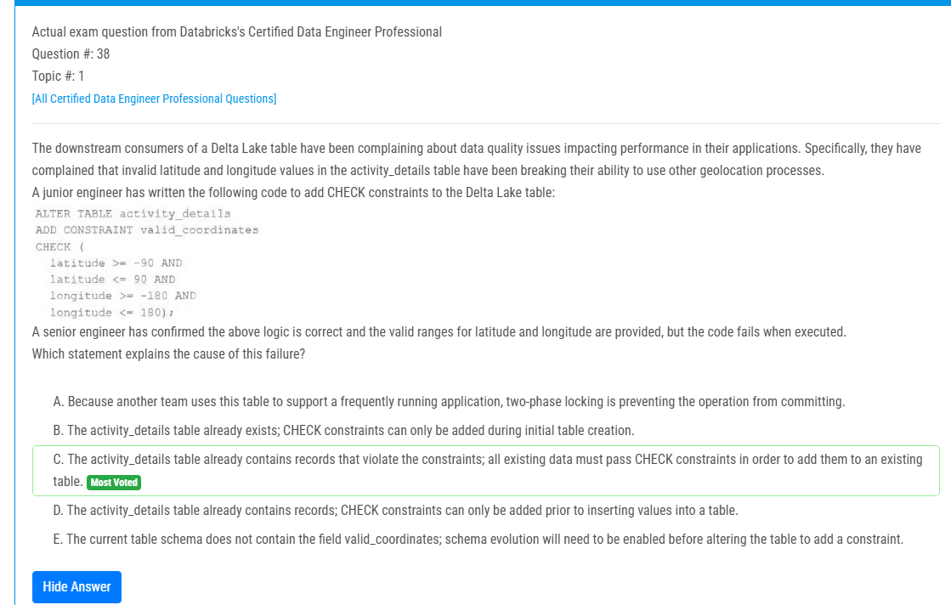

36.

37. 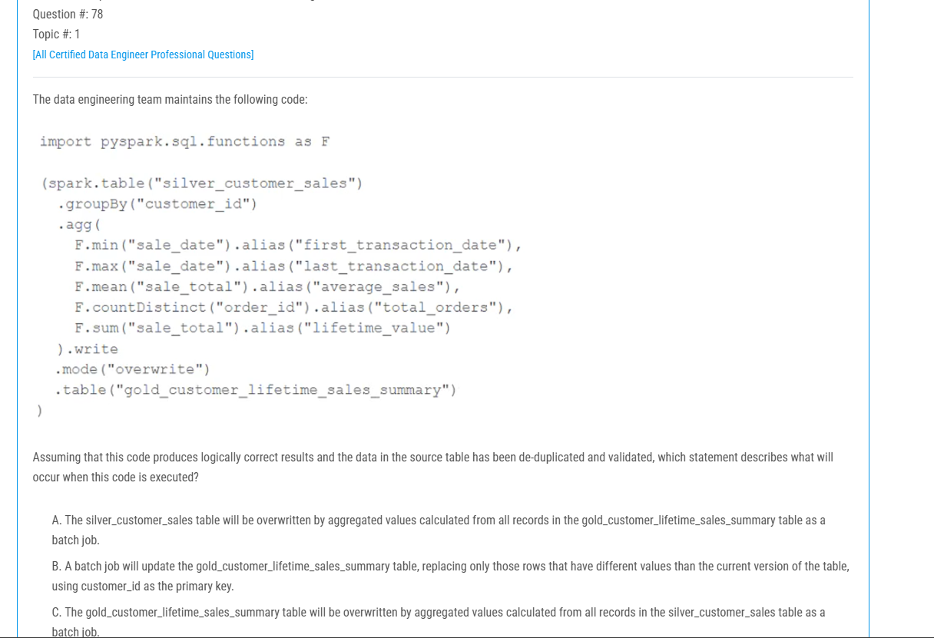  
39. 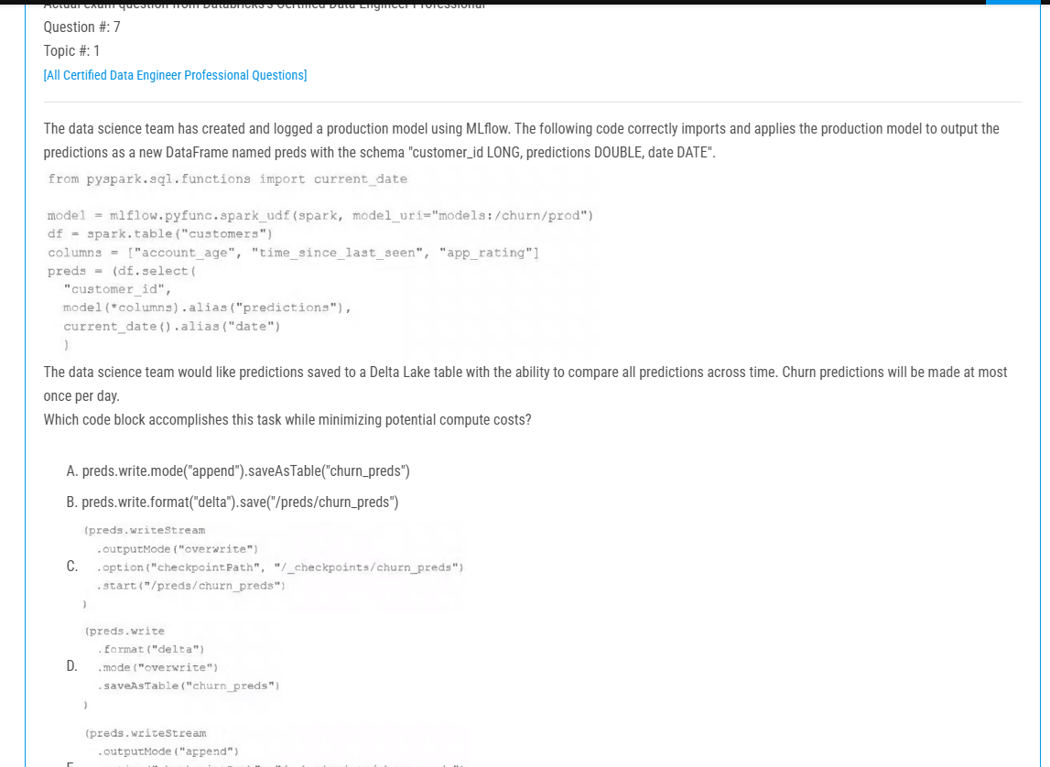

43.  
  
45.  
